GitHub Actions CI/CD Lab – Web App

Lab Overview
This lab walks through building a real-world CI/CD pipeline using GitHub Actions for a simple web application.
You will build, test, deploy, break, and fix a web app using automation.

Scenario
You are part of a development team responsible for automating build, test, and deployment for a web app.
Every change must be validated and deployed automatically.

Prerequisites
- GitHub account
- Git installed
- Basic HTML knowledge
- Basic Git usage

Step 1: Create the Web App
Create a new public GitHub repository named github-actions-webapp.

Create a file called index.html with the following content:
<!DOCTYPE html>
<html>
<head>
<title>GitHub Actions Lab</title>
</head>
<body>
<h1>Hello from GitHub Actions</h1>
<p>This site is deployed automatically.</p>
</body>
</html>

Commit and push the file to the main branch.
Follow the instruction below if you are new to Git
Create a new repo in Git like 
In the same folder where index.html saved:
git init
git add .
git commit -m "first commit"
git branch -M main
git remote add origin https://github.com/<your GitHub user name>/githu-action1.git
git push -u origin main

Step 2: Create the Workflow
Create the following folder structure in your repository:
.github/workflows
Inside this folder, create a file called ci.yml.

Step 3: Define the Pipeline
Add the following GitHub Actions workflow to ci.yml:
name: Web App CI
on:
push:
branches: [ main ]

jobs:
build:
runs-on: ubuntu-latest
steps:
- name: Checkout code
uses: actions/checkout@v4

- name: Run HTML check
run: |
echo "Checking HTML files"
ls *.html || exit 1

- name: Upload artifact
uses: actions/upload-artifact@v4
with:
name: website
path: index.html

Save all files and then commit and push the workflow file.
git add .
git commit -m "second commit"
git push
Step 4: Observe the Pipeline
Select the Actions tab in GitHub.
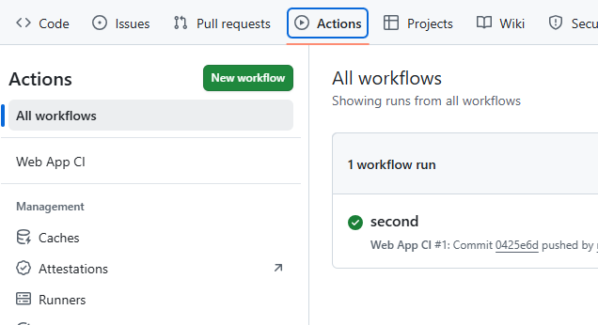
Click the workflow run and inspect each step output.

Step 5: Deploy to GitHub Pages
Github page is designed to host your personal, organisation, or project pages from a GitHub repository. Let’s gpst your app on the WWW!
Enable Github pages

Elect your repository and then go to its settings

Select Pages from the left menu
Then select Github Actions as source:
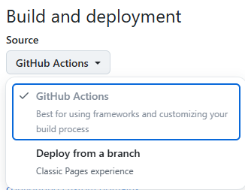
Update ci.yml with the following deployment workflow:
name: Web App CI

on:
push:
branches: [ main ]

permissions:
contents: read
pages: write
id-token: write

jobs:
deploy:
runs-on: ubuntu-latest
steps:
- name: Checkout
uses: actions/checkout@v4

- name: Configure Pages
uses: actions/configure-pages@v5

- name: Upload Pages artifact
uses: actions/upload-pages-artifact@v3
with:
path: .

- name: Deploy to GitHub Pages
uses: actions/deploy-pages@v4

Commit and push the changes.
You will see something similar in the Actions tab
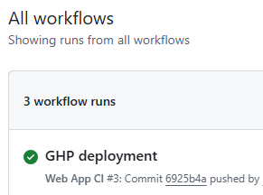

Step 7: View the Deployed App
Click the GitHub Pages URL when it appears (may take some time).
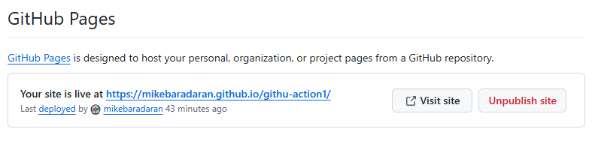
And view it in a browser and verify the content.

Step 8: Change the App
Edit index.html as follows:
<h1>Hello from GitHub Actions 🚀</h1>
<p>Pipeline triggered by a commit.</p>

Commit and push.
Observe the workflow rerun and refresh the website.
(wait before site is updated by Action)

Step 9: Break the Build
Rename index.html to home.html.
Change the Yaml file to:
name: Web App CI

on:
push:
branches: [ main ]

permissions:
contents: read
pages: write
id-token: write

jobs:
deploy:
runs-on: ubuntu-latest
steps:
- name: Checkout
uses: actions/checkout@v4

- name: Check if file exists
run: |
if [ -f "./index.html" ]; then
echo "File exists"
else
echo "File does NOT exist"
exit 1
fi

- name: Configure Pages
uses: actions/configure-pages@v5

- name: Upload Pages artifact
uses: actions/upload-pages-artifact@v3
with:
path: .

- name: Deploy to GitHub Pages
uses: actions/deploy-pages@v4
Commit and push.
Observe the workflow failure in GitHub Actions.

Step 10: Fix and Re-run
Rename home.html back to index.html.
Commit and push.
Confirm the workflow succeeds again.

Well done!

In this lab you have:
- Created GitHub Actions provides built-in CI/CD
- Observed that Pipelines run automatically on events
- Learned that failures are caught early
- Successfully implemented automation to enable safe deployments

